Dancing With the stars and Planets! Worksheet

**Course:** “Defy”ning Gravity:

**Materials:** Access to **PhET’s “My Solar System” Simulation**, a pencil, your imagination 🚀

**Created by:** Ryan Saelens

afebdc7c-7778-4e44-9f29-4d146b9ba50f.png

Mission Briefing:

You’re a **GALACTIC EXPLORER** with a **specific interest in gravity!** You’ve been sent by the Space Agency to mess with the universe, to see **how gravity keeps the cosmos in motion!** Use the **PhET simulation *My Solar System***to investigate what happens **when moons, planets, and stars hang out in space!**

**Your** **goal** isn’t to solve it all--just to **GET CURIOUS, OBSERVE,** and **HAVE FUN!**

During this lesson, **you will be asked to do the following:**

* Run the simulation
* Complete activities
* Summarize findings
* Answer questions

Learning Goals:

* **Explore** how gravity **affects motion in space**
* **Observe** how **mass and velocity influence orbits**
* **Practice** scientific thinking through **prediction, observation, and systems design**

Quick Vocab:

**Binary System** – Two stars orbiting a shared center of mass.

**Center of Mass** - The **“balancing point”** between two objects being pulled by gravity.

**Elliptical Orbit** – A **stretched-out circular path.**

**Momentum** – **How much motion** something has, **based on its mass and velocity.**

**Stability** – When a **system** stays **balanced or predictable.**

**System** – **A group of things** that **interact together** (like a star, planet, and moon).

**Trajectory** – The **path** something follows as **it moves through space.**

Module 1: Start with sun & earth

To **access/open** the **PhET simulation *My Solar System***, click [**HERE!**](https://phet.colorado.edu/sims/html/my-solar-system/latest/my-solar-system_all.html)

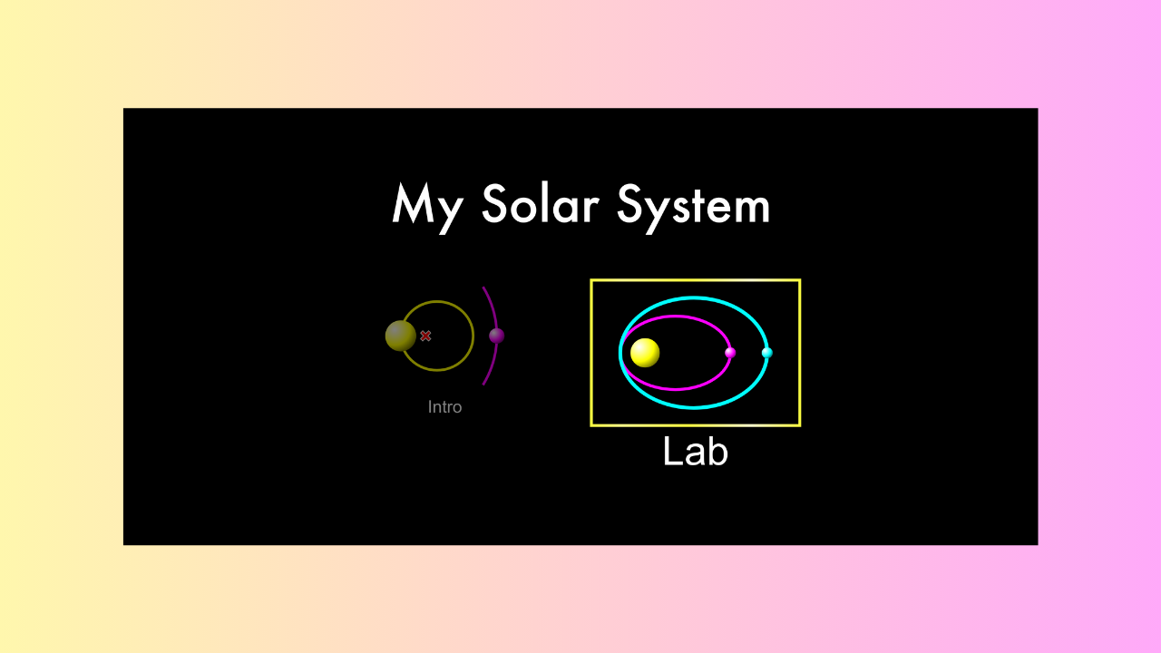

* You should see an option that says **INTRO** and one that says **LAB** 
  + **CLICK** on **LAB** (INTRO is a simpler version, though **LAB is where the fun happens!**)
    - Make sure your **SOUND** is **UP!**

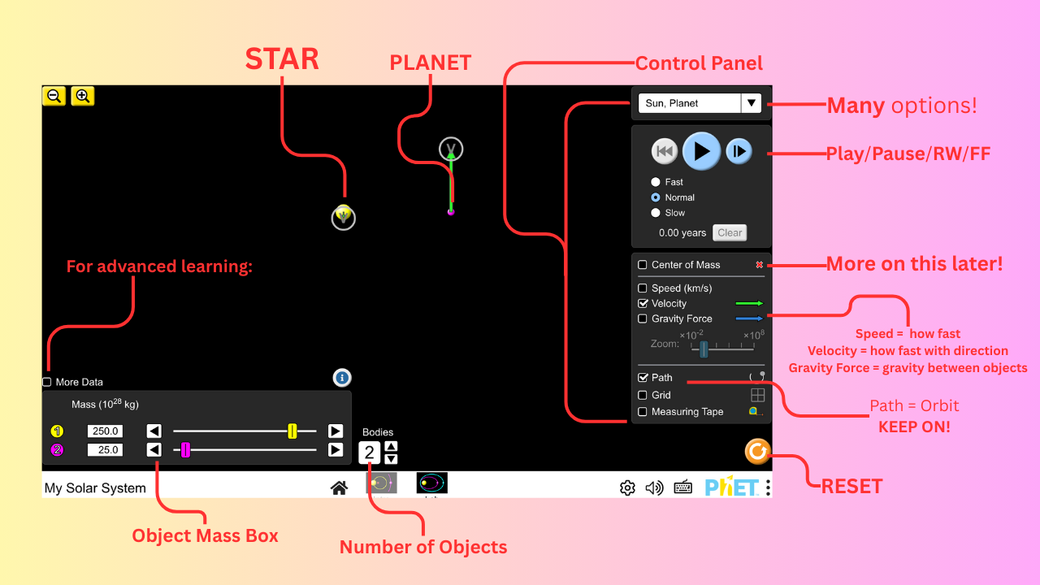

* You should see two objects in the middle of the screen ⟶ a **STAR** and a **PLANET!** 
  + It should be titled **“Sun, Planet”** in the **top-right of the Control Panel.** 
    - **Use the diagram above to learn the layout of the simulation!**
  + **HIT** the **PLAY BUTTON** and watch how the planet moves!
    - Describe what you see!
  + What kind of path does it make?
    - Straight
    - Wiggly
    - Round-ish
    - TOTAL CHAOS
* **TRY THIS:** 
  + **PAUSE** the simulation.
    - Increase the planet’s mass (bottom-left of the screen).

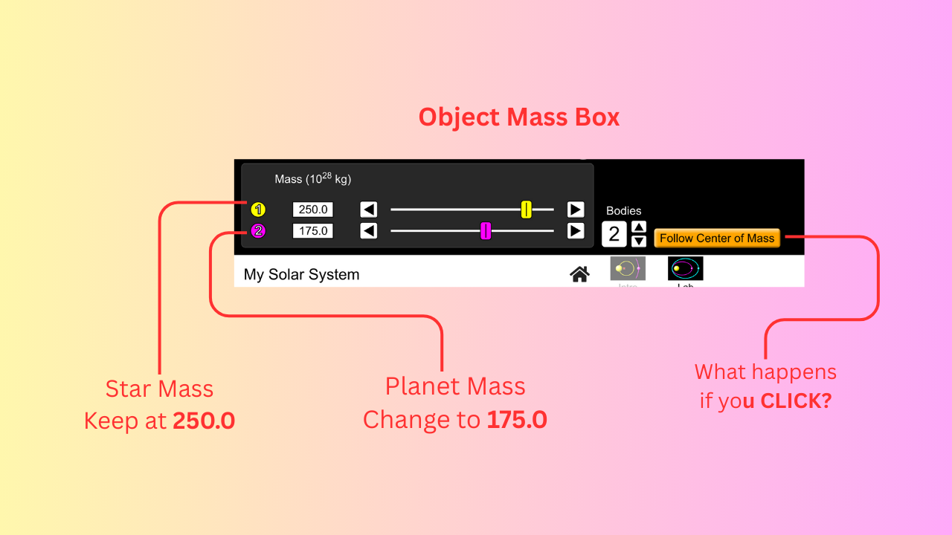

* + - **HIT PLAY!**
  + What changes? **Circle the correct option below:** 
    - The planet moves faster.
    - The planet crashes into the star.
    - The planet and the star break from orbit and spiral around each other.
    - Nothing changes between the planet and the star.

Module 2: Play with the Planets!

**RESET** the simulation and then **choose the option titled “Ellipses”** from the Control Panel in the top-right.

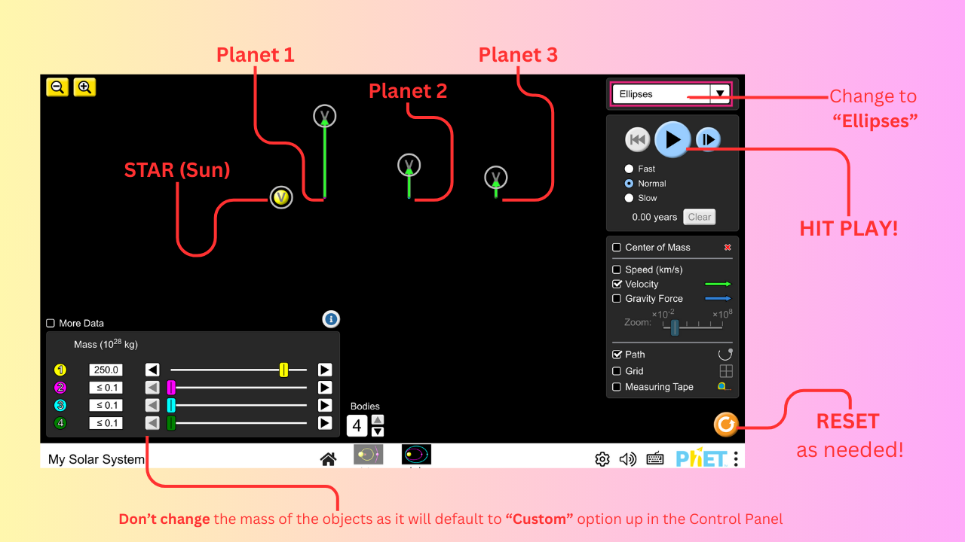

* This should show you a setup that **resembles our solar system**, just on a much smaller scale and with less planets!
  + The Sun is in the middle and there are **THREE** planets orbiting around it!
    - **NOTE:** It takes a lot of computer power to simulate objects. THREE will suffice to obtain an understanding of how planets orbit stars, like our Sun. **YES, OUR SUN IS A STAR!** Kinda cool, huh? 🙂
* **HIT PLAY** and let the simulation run for a moment.
* **PAUSE** the simulation.
  + **WRITE DOWN** the behavior of the planets and **DRAW** theirs orbits below!

**Use the space below to draw what you see. Draw the planets, their orbits and briefly explain the behavior of each one:**

* What happens to the planets if you **slowly decrease the mass of the Sun** (the yellow sphere)?
  + Please explain below.

* **RESET** the simulation and **choose “Ellipses” again!**
* **HIT** the **PLAY** **BUTTON.**
* What happens if you **increase the mass of sphere #3** (the light-blue sphere)?
  + Please explain below.

Module 3: Mix it up!

**RESET** the simulation and then **REPEAT** the process from **Module 2** **THREE MORE TIMES** using options of **YOUR** choice! **Be sure to RESET the simulation** in between trials.

* + **Example:** Choose **“Sun, Planet, Comet”** or if you really what to get crazy, choose something like **“Double Double”!**
  + Like before, **make a prediction** of what you think will happen **FIRST!**
  + Then **HIT PLAY.**
  + **Explain what you observe happening** as the simulation runs
    - **REMEMBER** to **PAUSE** if needed!

Please use **the spaces below** to **WRITE DOWN** and **DRAW** predictions and observations!

In the ***Prediction*** area, write down what you think will happen, followed by a drawing of what you think the orbits of the objects will look like.

In the ***Observations*** area, write down what you observe happening, followed by a drawing of the actual orbits of the objects.

Be sure to **LABEL YOUR OBJECTS** so you know which is which!

**Option #1:**

What option did you choose?

**Prediction:**

**Observation:**

**Option #2:**

What option did you choose?

**Prediction:**

**Observation:**

**Option #3:**

What option did you choose?

**Prediction:**

**Observation:**

Module 4: Solar System Creation!

Using the option titled, **“Custom”**, design **YOUR OWN SOLAR SYSTEM** that doesn’t blow up for at least 10 seconds.

* USE **4 objects!** (Use the up arrow by the number display that says “Bodies”)
  + Refer to the layout image at the top of this worksheet **for help!**
* Explain below what you **had to change** to make it work.
* Then **DRAW** the **SHAPES** of the orbits!
  + Remember to **label your objects!**

**What did you have to change to create a (somewhat) stable solar system?**

**Please draw the orbits of the objects in your solar system below** (Remember to **label!**)

Module 5: Multiple Choice Questions

For each question, **choose** **which answer** you think **fits best.**

1. **The gravity of the Sun is so strong that it:** 
   1. Pushes the planets away.
   2. Scatters the planets around in a circle.
   3. Pulls the planets towards its center.
   4. The Sun has no gravity.
2. **If the Sun suddenly decreases in size (mass) down to nothing, what do you think happens to the Earth? You can test this by using the “Sun, Planet” option. Click play and decrease the mass of the Sun down to nothing.** 
   1. Nothing different happens. The planet stays in orbit around the Sun.
   2. The planet stays in orbit but speeds up.
   3. The planet obtains a larger orbit.
   4. The planet flies off into space.
3. **Choose “Sun, Planet, Comet” option from the Control Panel in the top-right. Let it run for a moment. Then choose the option below that best explains what you see.** 
   1. The comet and planet crash into each other immediately.
   2. The Earth flies off into space, but the comet stays in orbit.
   3. Both the comet and the Earth orbit the Sun, though the comet is a lot faster than the Earth.
   4. The comet and Earth share an orbit around the Sun.
4. **Choose “Ellipses” option from the Control Panel in the top-right. CHECK the SPEED box and keep the VELOCITY box checked. Let it run for a moment. Why do the planets ALL seem to speed up as they get closer to the Sun?** 
   1. The planets don’t speed up. They ALL slow down as they approach the Sun.
   2. Only the closest planet speeds up. The rest don’t change in speed.
   3. They change in speed because they decide to get faster.
   4. They ALL feel the Sun’s gravity, which increases as they get closer, forcing them to speed up.

Module 6: T/F Questions

Read each statement below and **decide whether it’s True or False.** Write **T** for **True** and **F** for **False.**

1. Only large objects, like planets and moons and have gravity.
2. If an object’s mass increases, it’s gravity increases.
3. Gravity is a force in the air that pushes objects toward one another.
4. Not all stars have gravity.
5. Asteroids aren’t affected by the force of gravity.

Module 7: Center of Mass Mystery (optional!)

This is an **OPTIONAL QUESTION** designed to get you **into the spirit of RESEARCH!**

* **RESET** the simulation and choose the **“Sun, Planet”** setup.
* **CHECK** the **“Center of Mass” box** in the Control Panel.

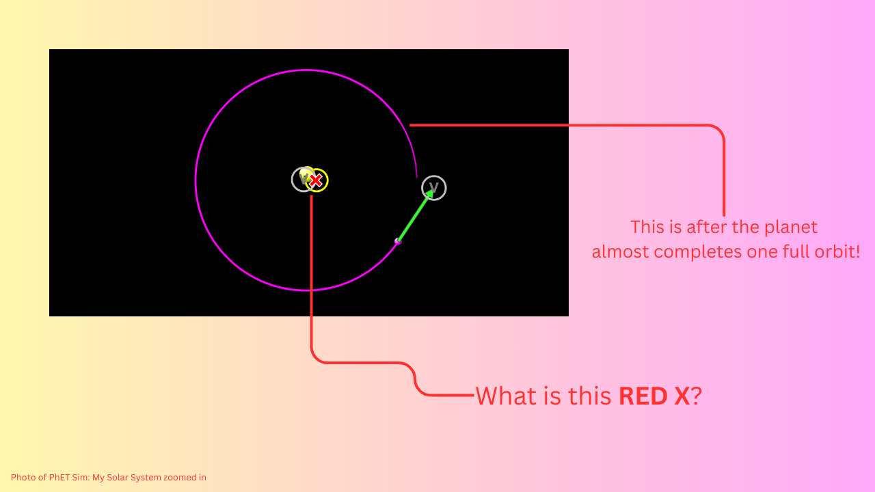

* + Suddenly...a mysterious **RED X** appears in the simulation
* **The Sun is orbiting that X** instead of just sitting still. **Hmm...** 
  + What is that **X**?
* Use your **research superpowers** (books, internet, wise owls, etc.) to find out:
  + What is the **RED X** called **in science terms**?
    - **HINT: It starts with a “B”.**
* In **your own words** (or PICTURES) please **answer the following questions below.**
* **DRAWING** is highly encouraged!

* + How is the Sun’s orbit in the simulation **different** **from** how it moves in **real life?**

* + Where is the Center of Mass **located in real life**?

* + Does the Sun orbit **anything?**

Some Fun Facts

* You’re flying through space at **67,000 mph** with Earth right now!
* Most **orbits are oval-shaped, not perfect circles.** We call this shape an ***ellipse.***(You’ll learn more about this when you get introduced to **Kepler’s Laws of Planetary Motion!**)
* Even **the Sun wobbles slightly**--thanks to the planets pulling on it!

**\*\* Save ALL work and notes to add to your portfolio!**

Now, go claim your Certificate of completion!